

Macroeconomics 2

Moodle blocks 5

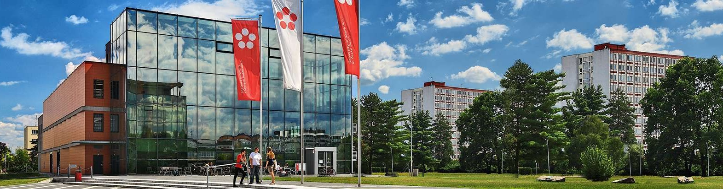

Jihočeská univerzita v Českých Budějovicích

Branišovská 1645/31a

370 05 České Budějovice

IČ: 60076658

The four sectoral model of the economy

Y (GDP) = C + I + G + NX

M = Ma + mY Ma - autonomous import m – marginal propensity to import

                                                                   1

multiplier of open economy = ----------------------------

                                                               1-c (1-t) + m

I = Ia - bi b – Coefficient of the sensitivity demand for investing in interest rates

                         1

Yo = --------------------- * Aa4

            1-c (1-t) + m

m - the marginal propensity to import from retirement

Equilibrium (Yo)

What are the main causes of foreign trade?

What tools are used to curb import of goods from abroad?

And what does the net export function of NX look like and why is export autonomous?

Use the following data Ca = 100 Ia = 50 Ga = 80 Xa = 5 c = 0,8 m = 0,14 t = 0,2

Ma = 20 TRa = 25

a) the value of the multiplier and the equilibrium expenditure (product)

b) if the TR increases by 30 units as the equilibrium product changes

The open economy is characterized as follows: C = 200 + 0,7YD M = 220 + 0,1Y t = 0,25 I = 1800

In the initial situation, government expenditure in the amount of G = 500 was used at the tax rate t = 0,25. Exports of goods were equal to X = 600

a) Identify the open economy multiplier, GDP, and NX (net exports)

b) After a certain period of time, foreign direct investment was driven by 25% export growth. Determine how the product changed and the net export of the country

c) What would be the value of export to increase the original GDP by 2,5%

The open economy is characterized as follows:

C = 400 + 0,6 (Y-0,3Y) G = 800 X = 400 I = 1600 M = 200 + 0,06 Y

Specify

a) the original Y and NX values

b) the initial level of import and balances of the state budget

c) the new value Y and NX if the export is increased by 15%

What are the basic methods for calculating GDP?

How is the Czech Statistical Office (CR) currently calculating GDP?

What is the difference between Gross Domestic and Gross National Income (product) and which is bigger in the Czech Republic.

economic data

government expenditure (G) ...................... .... 860

export (X) ....... ........................ ....... 1377

wages (w) ...... .. .............................. .. 2100

import (M) ............... ... ............ .. ...... 1537

rents (r) ......... .. ..................... .... 300

indirect taxes (Tn) ................... ... .. ... .. 120

profits of companies .......... ..................... .. ...... 500

interest on loans (iu) ................... ... .. .... ... 1020

interest on deposits (iv) ... ...................... ... .1320

amortization (A) ................................. .500

household consumption expenditure (C) .... 1200

Calculate:

a) amount of GDP

b) Net domestic product

c) investments

Data about a particular economy are:

|  |  |
| --- | --- |
|  | Quantity in CHF bill |
| direct taxes | 650 |
| government expendirure | 970 |
| export | 900 |
| wages | 2000 |
| import | 500 |
| pensions of foreigners reached in the Czech Republic | 390 |
| household consumption expenditure | 1200 |
| amortization | 500 |
| transfers | 100 |
| Gross private investments | 1000 |
| Indirect taxes | 60 |
| pensions of domestic residents abroad | 120 |

Calculate:

a) Gross Domestic Product (NDP)

b) Disposable income

c) Household savings (S)

d) Gross national product

e) Net national product