**Reasons and causes of change**

Change is an inevitable aspect of life. It is the essence of any entity, that has life or whose existence finds validity in the presence of life. Even time would lose its signifikance in the absence of change. As change manifests itself in a variety of ways, it doesn´t hold the same connotation across people, situations, and contexts. Times change, people change, things change, situations change, and so do organisations. The world is constantly changing around us, both in our private and our worrking lives (Shama, 2006).

We are living in the world, where change is a normal and something that occurs every day in organizations of any kinds. Our today’s expectations are larger than those yesterday. Our expectations for tomorrow are much bigger than today’s (Entrepreneurshipinabox.com, 2018).

Customer’s expectations are changing with much greater speed than in the past. Suppliers change their way of doing business. Partners are different over time. The interest of different stakeholders as a part of closed environment of organizations is different over time. Outside changes will appear regardless companies want them or not (Entrepreneurshipinabox.com, 2018).

Discovering different sources of organizational change as quickly as possible, becomes one of the key competitive advantages of today’s small and medium sized companies (Entrepreneurshipinabox.com, 2018).

The need for change is based on the influence of both internal and external affluence. Changes are caused either by changes in environmental conditions or by internal pressures. Some influences are well-known and descriptive - direct influences that directly affect the organization - or some indirect forces that can be described as forces that affect the environment, in which the organization is moving (Reiss, 2012). Indirect influences Direct influences Internal influences - Political - Economical - Technological - Social - Competition - Suppliers - Customers - Stakeholders - Equipment - Finances - Human Resources - Khow-how

Among the indirect influences we include political decisions, election results, legislative processes, etc. Other indirect influences include changing macroeconomic indicators, changes in habits and perceptions of technology in the social sphere, then new inventions, innovations and working practices. Direct effects may be, for example competition, supplier changes and structure, changing customer needs and requirements, and the impact of groups that are interested in the organization's activities in both positive and negative terms (Reiss, 2012).

Internal sources of pressures to introduce changes include, for example, poor equipment and insufficient use of information technology, inappropriate financial management of the company and insufficient cash flow, inadequate staff qualification

structure, or inaccessibility of patent solutions and modern technologies. Therefore, the organization has a whole complex of forces that forces it to respond to it by change (Reiss, 2012).

Managers must contend with all factors that affect their organizations. The following lists internal and external environmental factors that can encourage organizational changes:

• The external environment is affected by political, social, technological, and economic stimuli outside of the organization that cause changes.

• The internal environment is affected by the organization's management policies and styles, systems, and procedures, as well as employee attitudes (Cliffsnotes.com, 2016.)

It is important for change management to know, how the change is taking place. Causes can also be broken down by type of change:

1) Change spontaneous - this change takes place without human intervention, by the action of natural forces and influence. Self-change is almost always a change that leads to a deterioration of the object, for example material corrosion, physical or moral obsolescence of the machine. This change is conditioned by three types of causes.

• Deterministic causes - they act continuously and there are no exceptions for example is an oxidation.

• Artificial causes - man-made influences that act on the outside organization for example legislative norms, cultural rules of behavior etc.

• Random causes - they act randomly and can not usually be predicted. These are mainly natural impacts (floods, storms, etc.)

2) Change-driven (or targeted) change that is the result of a purposeful and conscious business aktivity, that is based inside the organization and which goes to a predetermined purpose eg material treatment to avoid corrosion, machinery renewal and upgrading, development and implementation qualitatively new product, change in company processes, change of strategy (Newton, 2012).

In business, change is a constant, so organizations are always adapting to meet market demand. Whether internal or external, change in an organization has different causes. Knowing, what these causes are is an essential part of business management. Employees must also be aware of what causes organizational change, because it inevitably affects them as well (Sheer & kol., 2012).

In just a few months, the technology that an organization uses on an everyday basis may be outdated and replaced. That means an organization needs to be responsive to advances in the technological environment; its employees' work skills must evolve as technology evolves. Organizations that refuse to adapt are likely to be the ones that won't be around in a few short years. If an organization wants to survive and prosper, its managers must continually innovate and adapt to new situations (Bizfluent.com, 2017).

Every organization goes through periods of transformation that can cause stress and uncertainty. To be successful, organizations must embrace many types of change.

Businesses must develop improved production technologies, create new products desired in the marketplace, implement new administrative systems, and upgrade employees' skills. Organizations that adapt successfully are both profitable and admired (Bizfluent.com, 2017).

Just as important for aceptance of change is an understanding, why the change has to take place. Thus, the reason for this change are to be openly an clearly stated. staff will understand the reason for the change from a logical / thematic standpoint before they alco lend their emotional support as well. Here, too, it cannot suffice to communicate the reasons for change at the company level, instead, a clear explanation should be made as to why a particular staff member´s area must changed, and in which direction (Sheer & kol., 2012).

The main reasons for changes in the organization are:

End-of-Life Products

After some time, market demand for a company's product may diminish. This will then cause the company's profits to drop, and ultimately force the company to abandon the product for a newer source of revenue. In other words, when a product reaches the end of its life, the company discontinues it and moves on to something new. When this happens, the company transfers labor and funding to the new product, which may impact the type of work the company performs - and how - going forward.

Government Change

Government employees may find that when a change in government takes place – for example, when a new president is elected and consequently a new administration - the new administration may stop certain existing projects. A new government means a new political agenda. As a result, the biggest problem is that this can completely warp the way the governmental organization conducts affairs or even result in layoffs or redundancies, two departments doing the same thing.

Mergers and Acquisitions

Mergers and acquisitions are causes of organizational change that many people are familiar with from the news. When two companies come together, it re-creates their very structures. The acquiring organization may wish to cut its expenses and reallocate some resources to new products or services. Basically, this change can involve reducing the amount of workers or altering the nature of staff jobs.

Strategy Change

Sometimes, a company may change its priorities. For example, an organization might decide to move from focusing on a product to focusing on a service. This will create a demand for new types of marketing and production, while at the same time requiring a shift in strategy. All of these factors combined can trigger massive change.

Structural Change

There will come a time when an organization overhauls its administrative strategies –in other words, the managers and human resources professionals change the way they organize the business. For example, they could introduce new methods of bookkeeping, such as going from paper files to digital files. This would require massive retraining for all

employees involved. Even smaller-scale improvements, like updating software, will still cause some change (Bizfluent.com, 2017).

Organizations change for a number of different reasons, so they can either react to these reasons or be ahead of them. These next reasons include:

Crisis

Obviously September 11 is the most dramatic example of a crisis which caused countless organizations, and even industries such as airlines and travel, to change. The recent financial crisis obviously created many changes in the financial services industry as organizations attempted to survive.

Performance Gaps

The organization's goals and objectives are not being met or other organizational needs are not being satisfied. Changes are required to close these gaps.

New Technology

Identification of new technology and more efficient and economical methods to perform work.

Identification of Opportunities

Opportunities are identified in the market place that the organization needs to pursue in order to increase its competitiveness.

Reaction to Internal & External Pressure

Management and employees, particularly those in organized unions often exert pressure for change. External pressures come from many areas, including customers, competition, changing government regulations, shareholders, financial markets, and other factors in the organization's external environment.

Change for the Sake of Change

Often times an organization will appoint a new CEO. In order to prove to the board he is doing something, he will make changes just for their own sake.

Sounds Good

Another reason organizations may institute certain changes is that other organizations are doing so (such as the old quality circles and re-engineering fads). It sounds good, so the organization tries it.

Planned Abandonment

Changes as a result of abandoning declining products, markets, or subsidiaries and allocating resources to innovation and new opportunities (Processexcellencenetwork.com,2011).

Changes in the organizational structure are due to the following reasons:

• Reduce the costs associated with reducing employee numbers. The need to reduce the number of employees can be triggered by a variety of situations, such as lower demand for company products, increased labor productivity achieved by more efficient equipment, or better quality of employees and management, or higher automation through information technology.

• Business growth can be achieved by getting a new project or starting a new product. An example of organizational change in the growth of a company may be the production of a new type of car that we need to move some existing employees from operations. Growth of the company may be associated with the adoption of more new jobs due to increased demand for existing products. The cause is also the diversification of the production, when we add to the existing products another, new product line.

• Changing the overall company layout. Changes can lead to new customer requirements or a comparison of our own organizational structure with competitors' structures. For example, creating a holding structure with several legally separate organizational units or outsourcing some of the activities. Changes are usually triggered by mergers or acquisitions, when two or more (Nibusinessinfo.co.uk, 2011).

The main reason for restructuring your business is to allow it to achieve its strategic objectives. A business often needs to make changes, when it reaches a new stage in its life cycle. This can include moving from an entrepreneurial organization to one with a more stable, planned development (Nibusinessinfo.co.uk, 2011).

You may also choose to restructure your business due to:

• business growth

• change in management, eg taking on a partner

• moving into new product lines

• expanding your business overseas (Nibusinessinfo.co.uk, 2011).

Other factors, both internal and external, can also prompt change to your organizational structure. Read about the benefits and common barriers to organizational change (Nibusinessinfo.co.uk, 2011).

External factors affecting organizational change

External factors that might prompt a change in your business' structure include having to:

• address new markets

• react to changes in product or service demand

• keep up with new technologies or products from competitors

Zuzana Gučíková, ŘEPN 2018

Other external events that can affect either your business or your rivals can also stimulate organizational change. These include, for example:

• mergers and acquisitions

• joint ventures and business partnerships

• preparing to sell your business (Nibusinessinfo.co.uk, 2011).

Internal factors affecting organizational change

Internal business needs can also prompt positive business change. For example, these may include the need:

• to raise additional capital, improve cash flow or profitability of your business

• to address outdated and inefficient working practices and processes

• to eliminate excess job positions and remove duplicate management roles

• to reorganize your internal functions for efficiency, such as sales and marketing (Nibusinessinfo.co.uk, 2011).

**LEADERSHIP AND PARTICIPIENTS OF THE CHANGE**

What is the ideal way to develop leadership? Every society provides its own answer to this question, and each, in groping for answers, defines its deepest concerns about the purposes, distributions, and uses of power. Business has contributed its answer to the leadership question by evolving a new breed called the manager (“Managers and Leaders: Are They Different?”, 2004).

In today’s challenging and rapidly changing marketplace, managing partners need to do much more than “manage”—they have to demonstrate true leadership to get their firms around the twists and turns to long-term success. Effective leaders develop a clear vision of where they want their constituents to go, and then they lead those constituents there in a way that makes them voluntarily want to follow.

While these two tasks may seem straightforward on the surface, in actual practice there are myriad ways to carry them out. Some manuals urge leaders to emulate warrior chieftains (like Wess Roberts's The Leadership Secrets of Attila the Hun), while others advocate a gentler approach (like Laurie Beth Jones's Jesus, CEO). It's important, though, to recognize that one size does not fit all. People differ, bringing a variety of skills and personality traits to the role. And not all situations are similar or static. A style that works well in one firm, with one culture, might be disastrous in another firm facing a different set of challenges.

Research seems to show that the best leaders have a certain flexibility in their approach, an ability to match their style to the situation. Some leadership styles are simply more effective in certain situations than others. However, the challenge is not simply an intellectual one, matching the style to the needs of the firm. The best leaders use a combination of intellect and emotional savvy. They choose the style that best fits the situation and then skillfully use emotions-their own and others'-to get the job done.

There are six different **leadership styles** identified by research:

1. Visionary

2. Mentoring

3. Affiliative

4. Participative

5. Pacesetting

6. Commanding (“Six Styles of Leadership: How Will You Handle Your Firm's Reins?”, 2008).

**Leadership vs. management**

Leadership and management must go hand in hand. They are not the same thing. But they are necessarily linked, and complementary. Any effort to separate the two is likely to cause more problems than it solves (“What is the Difference Between Management and Leadership?”, 2009).

Still, much ink has been spent delineating the differences. The manager’s job is to plan, organize and coordinate. The leader’s job is to inspire and motivate.

The words "leader" and "manager" are often used interchangeably, but they mean two completely different things. 2

Manager tells:“ This is what I want you to do, and her eis how I want you to do it.“ Leader sells: „I have this great idea, and I know it will work if I can get you to be a part o fit.“

Manager plans the details, minimizes risks, instructs employees, has objectives, meets expectations, eyes the bottom line, accepts the status quo, sees a problem, thinks short-term, follows the map, approves, establishes rules, assigns duties, votes with their head, relies on control and does things right.

Leader sets the direction, takes risks, encourages people, has vision, charts new growth, eyes the horizon, challenges the status quo, sees an opportunity, thinks long-term, carves new roads, motivates, breaks rules, fosters ideas, votes with their heart, inspires trust and does the right thing (“17 of the biggest differences between managers and leaders”, 2016).

**Women as a leader**

Women remain under-represented in top leadership positions in work organizations, a reality that reflects a variety of barriers that create a glass ceiling effect. However, some women do attain top leadership positions, leading scholars to probe under what conditions women are promoted despite seemingly intractable and well-documented barriers (“Women and Top Leadership Positions: Towards an Institutional Analysis”, 2013).

There are subtle yet consequential barriers that prevent or severely challenge women from reaching top-level positions in their organizations. These barriers are represented by the effects that stereotypes and prejudice have on these effects are driven by people´s need to understand, belong, control, and enhance. Thus, the proposed model and review are consistent with the social bias framework. In a sequential and casual way, this ceiling model proposes that societal constraints and interpersonal constraints can influence the woman´s own internal constraints and/or the differential treatment she receives in the workplace (*Women as transformational leaders*, c2011).

In the United States, women are increasingly praised for having excellent skills for leadership and, in fact, women, more than men, manifest leadership styles associated with effective performance as leaders. Nevertheless, more people prefer male than female bosses, and it is more difficult for women than men to become leaders and to succeed in male-dominated leadership roles. This mix of apparent advantage and disadvantage that women leaders experience reflects the considerable progress toward gender equality that has taken place in both attitudes and behavior, coupled with the lack of complete attainment of this goal.

In contemporary culture of the United States, women on the one hand are lauded as having the right combination of skills for leadership, yielding superior leadership styles and outstanding effectiveness. On the other hand, there appears to be widespread recognition that women often come in second to men in competitions to attain leadership positions. Women are still portrayed as suffering disadvantage in access to leadership positions as well as prejudice and resistance when they occupy these roles (“FEMALE LEADERSHIP ADVANTAGE AND DISADVANTAGE: RESOLVING THE CONTRADICTIONS”, 2007).

Many women have contended successfully with barriers to their leadership, as shown by the fact that women now have far more access to leadership roles than at any other period in history. This access is especially great in the United States, where women constitute 24% of the chief executives of organizations, 37% of all managers, and 43% of individuals in management, 3

financial, and financial operations occupations (“Women in the Labor Force: A Databook”, 2006).

Are women excellent leaders, perhaps even better than men, on average or in some circumstances? To address these issues, researchers first have to answer the question of what good leadership is—what behaviors characterize effective leaders? Does effective leadership consist of the resolute execution of authority, the ability to support and inspire others, or skill in motivating teams to engage in collaborative efforts? All such characterizations of good leadership probably have some validity (“FEMALE LEADERSHIP ADVANTAGE AND DISADVANTAGE: RESOLVING THE CONTRADICTIONS”, 2007).

As situational theorists of leadership contend, the appropriateness of particular types of leader behaviors depends on the context—features such as societal values, the culture of organizations, the nature of the task, and the characteristics of followers. Yet, despite this situational variability, leadership has historically been depicted primarily in masculine terms, and many theories of leadership have focused mainly on stereotypically masculine qualities (John B. Miner., 1993).

Although prejudicial attitudes do not invariably produce discriminatory behavior, such attitudes can limit women's access to leadership roles and foster discriminatory evaluations when they occupy such roles. Social scientists have evaluated women's access to leadership roles through a large number of studies that implement regression methods (“FEMALE LEADERSHIP ADVANTAGE AND DISADVANTAGE: RESOLVING THE CONTRADICTIONS”, 2007).

The majority of women (leaders) defined leadership in terms of listening, empowering others, being collaborative, facilitating change, mentoring others, and being effective communicators. In addition, most of the women indicated that encouragement, equality, and the presence of role models are necessary in other to achieve their visions of being good leaders (*Women as transformational leaders*, c2011).

**T**

**he World's Greatest Leaders**

Historically Greatest Leaders

The world changes every day. People are born and people die everything and yet, life goes on. But in this everyday normal things of life, sometimes, people who have a different flair and ability to influence a whole lot of other people are born. These are some gems because of their sheer presence and charisma and whether or not these people use their talent for good things has always been a nature vs nurture debate. But the world has seen many great leaders in all the parts of the world but some of the leaders have had not only an influence on their own countries but on the world. Now of course, such a list is always subjective (“Top 15 Greatest Leaders of All Time”, 2017).

For good or for bad, our leaders can be powerful forces for change in the world. But who are the most impaction people to ever hold prominent positions of power? This is a list of the most important and influential leaders in the history of the world. Who are the most important world leaders? But remember: the most influential leaders (those who changed the face of world politics and forever altered their own countries) weren't necessarily good leaders. Some famous conquerors changed the world but let destruction in their wake. Others actually worked for the good of their people and became the great leaders in history. So, who are the historical leaders 4

that left their permanent mark (for good or bad)? (“The Most Important Leaders in World History”, 2017).

1. George Washington

2. Abraham Lincoln

3. Alexander The Great

4. Thomas Jefferson

5. Martin Luther King Jr.

6. Augustus Caesar

7. Napoleon Bonaparte

8. Charlemagne

9. Donald Trump

10. James Madison

|  |  |  |  |
| --- | --- | --- | --- |
| *Chart 1: Gratest Leaders in 2017* **RANK** | **NAME** | **TITLE** | **AFFILIATION** |
| 1 | Theo Epstein | President, Baseball Operations | Chicago Cubs |
| 2 | Jack Ma | Executive Chairman | Alibaba Group |
| 3 | Pope Francis | Head of the Roman Catholic Church | - |
| 4 | Melinda Gates | Cochair | Bill & Melinda Gates Foundation |
| 5 | Jeff Bezos | Founder and CEO | Amazon |
| 6 | Ava DuVernay | Film Director and Screenwriter | - |
| 7 | H.R. McMaster | U.S. National Security Adviser | - |
| 8 | Tsai Ing-Wen | President | Taiwan |
| 9 | John McCain | U.S Senator | Arizona |
| 10 | Angela Merkel | Chancellor | Germany |

**Types of Change**

To change is to move from the present to the future, form a known state to a relatively unknown state (Harigopal, 2006).

In order to understand the most effective change management methods for a given situation, it is crucial to understand the exact nature of the change. That is, there are different types of change within companies and it is helpful to distinguish them form one another in order to understand the varying types of change management that each change requires. Linda Anderson defines the three basic types of change as developmental change, transitional change, and transformational change.

Developmental change is probably the least disruptive of the three types of change that Anderson defines. Developmental change represents the imrovement of an existing sklil, method, performance standard, or condition that for some reason does not measure up to current or future needs.

Transitional change, on the other hand, is undertaken with the goal of fixing a specific problém. It represents a more difficult and more substantial amount of change than does developmental change. The change often focuses on the redesign of stratégy, structures, systems, process, technology, or work practices.

Transformational change, the Andersons write, is the least understood and most complex type of change facing organizations today. When led well, it can lead to extraordinary breakthrough results. When led poorly, it can lead to breakdown throughout the organization. Transformation is one of the most challenging yet potentially rewarding underakings for leaders (Akdeniz, 2014).

According to Tushman, Newman and Romanelli, organisations experience two kinds of change.

Tushman calls the minor incremental organizational change as convergence and the discontinuous change as the frame breking change or upheaval.

Other researchers have coined different terms to describe continuous and discountinuous change. For example Foss, Pascale and Athos (1993) use the term reinvention to describe discontinuous change. Nadler and Tushman refer to discountinuous change as strategic change, which they further distinguish into two types – reactive and anticipatory.

Implementation of change, as described in change management literature is broadly categorised into two approaches – the participative and the directive. The participative school of change impleentation propounds that organizational members should be involved and given opportunities to participate in planning and implementing change. Participation not only leads to better ideas but also reduces reasistance to change.

Directive school of change implementation holds that as discontinuous change needs to be rapidly implemented, participation is not essential as it is often time consuming (Sharma, 2007).

Change can be recognized and managed as a proactive initiative, or handled as a reactive response.

**Reactive Change**

When an unplanned event creates an uncomfortable situation or problematic condition, you´re forced to react to change.

Racting to change is a risky method of managing change. Although it´s sometimes unavoidable, it should never be considered a method of managing change. All lit takes to avoid reactive change is to understand that change is not only invevitable, but also necessary to maintain the quality of your life and to grow your business.

**Proactive Change**

It is much easier to deal with any situation when you expect it nad plan for it. That means assessing your situation and then setting a path for success based on pre-determinded goals and objectives (Lister, 2005).

For instance, Ralph Stacey distinguishes between three different types of events:

Closed change, where there is cerainty about what happened, why it happened nad what needs to be done.

Contained change, where we are reasonably confident about what happended, why it happended nad what needs to be done about it.

Open-ended change, where there is wide disagreement about what hapened, why it happened and what is to be done about it (Taylor & Francis, 2007).

Change management activities should be scaled based on the type and size of the change.

**Type 1 – incremental change:** In this change environment, a change will také place over a long period of time. The objectives of the change are small and deliberate improvements to a proven and successful business process. These types of changes are not normály driven by financial crisis or immediate demand for improvement, but rather a general focus on improving key business areas and specific operations over time. Examples of programs that result in incremental improvement include Six Sigma or continuous uality improvement methods such as TQM.

**Type 2 – Radical change:** In this environment, immediate and dramatic change is required over a short time period. Often driven by a crisis or significant opportunity facing the business, these changes are intended to produce dramatic performance improvements in business processes that are broken or no longer applicable to the current business conditions. The business change is often not an improvement on today´s processes, but rather a replacement of the processes with something brand new. Example initiatives that create radical change include business proces reengineering, regulatory changes, mergers and acquisitions (Hiatt, Jeffrey, Creasey, & Timothy, 2003).

Johnson and Scholes identify two different types of strategic change: incremental change and transformational chnage. In the main, strategic development in organisations is brought about through incremental change with the occasional need for more transformational change – usually in response to pressures or triggers in the external environment.

In both types of change the role of management can be proactive or reactive and the change management stratégy adopted will need to reflect this.

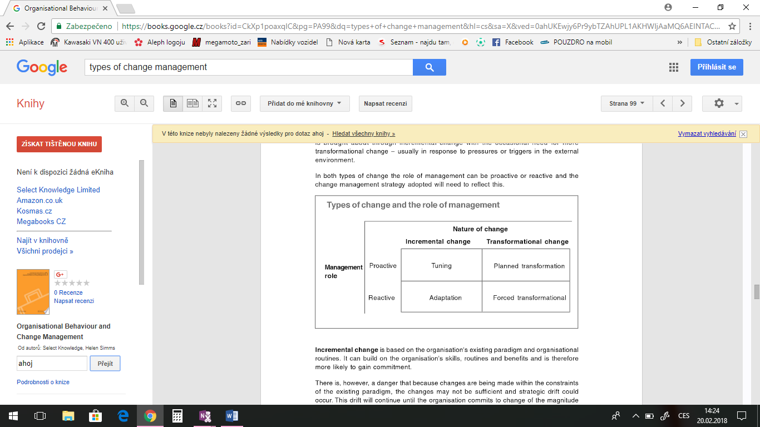

**Incremental change** is based on the organisation´s existing paradigm and organizational routines. It can build on the organisation´s skills, routines and benefits and is therefore more likely to gain commitment.

There is, however, a danger that because changes are being made within the constraints of the existing paradigm, the changes may not be sufficient and strategic drift could occur. This drift will continue until the organization commits to change of the magnitude demanded by changes in the evironment.

**Transofrmational change** is change which cannot be handled within the existing paradigm or organisationl routines. It may be palnned, for example to anticipate changes in the product markets in hich the organization operates, or forced, for example where an organization has drifted strategically to such an extent that it has become uncompetitive and is forced to implement a transformational change in order to survive (Knowledge & Simms, 2005).

Another distinctian between two forms of change is offered by Smith and Tranfield: i) morphostatic; and ii) morphogenic. While morphostatic change is concerned with adapting to a status quo position and where the issue is about deciding hich parameters need adjustment to bring things back to a steady state, morphogenic change is concerned with finding new and more approrpiate organizational forms.

Similarly, DeWit and Meyer differentiate between operational change and strategic change. Operational change, which is the most common type of change found in organisations focouses on enhancing the organisation´s performance within the limits of the current systém in order to align it with the environment. Strategic change, by contrast, aims to alter the organisation´s alignment with its environment. It is increasingly viewed as a shift in structures and processes as well as a reorientation of an organisation´s mission and purpose. In sum, while operational changes are necessary to maintain the business and organizational systems, strategic changes are directed at renewing them (Ramanathan, 2009).

**Change as extrinsic and revolutionary**

The external environment imposes various contingencies on the organization. Changes are called revolutionary when quantum change adically transforms many elements of a structure in an organization. From this perspective, organisations are conceived as stable structures and change is perceived as being disruptive in nature. To bring about change in the organization implies forcing the organization to modify, restructure or reconfigure. If the forces of change are beyond the tolerance level of the organization, it crumbles or its fate is assumed to be dependent ot the forces (Sharma, 2007).

Lawrence Hrebiniak of the Wharton School at the University of Pennsylvania offers a simple yet elegant Framework to conceptualise the challenges of executing change. According to him, the nature of change effort depends on two factors: a) size of the change problém or content of change, and b) time available for change. The size of the problém cold be large or small. The time available could be short or long, giving rise t four change scenarios.

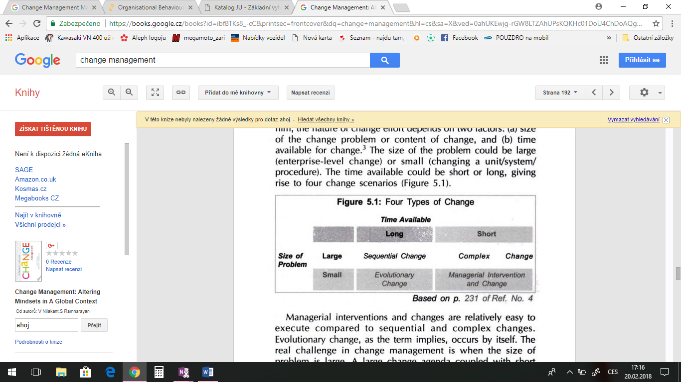

Managerial interventions and changes are relatively easy to execute compared to sequential and complex changes. Evolutionary change, as the term implies, occurs by itself. The real challenge in change management is when the size of problém is large. A large change agenda coupled with short timeframe is the most difficult type of organizational change that managers can face. Complex change, as the term implies, is the most difficult challenge in change management. We now examine this challenge in some detail (Nilakant & Ramnarayan, 2006).

Change is generally looked at as being continuous or discontinuous. In countinuous change (also known as continuous process improvement), the goal is to adjust systems and processes continually to fine-tune them and get the most you can out of what you currently have. For example, an auto manufacturer like Honda or Ford might adjust its production line to incorporate new features such as global positioning systems in its vehicles. This adjustment, while making the behicles different, would not require a major change in the production process and would be relatively easy to incorporate. Individuals generally do not get upset when they have to make this type of change.

Discontinuous change (sometimes also referred to as reengineering) involves a major change in business, processes, and people. Related to the first example, Honda or Ford might come up with a totally different type of vehicle, such as the hybrid or electric car. Here major processes would have to change, as would the way work gets done and the individuals involved in the process, who would likely be required to perform a new function or attend training and learn how to complete new tasks and follow new procedures. This type of change generally creates more emotion. Some individuals will be excited about the opportunity to try something new and different; others may be frustrated or fearful. As things change, so will individuals´standards. They may doubt their ability to do the new job as effectively as the old or to learn the new skills reuired as a result of training, or they may fear the change itself. Continuing with our earlier example, if the hybrid or electric car fails, will individuals be out of work (Vukotich, 2011)?

**Understanding the Requirements of Transformation**

The first task of change leadership is to understand the terrain of change and how it has evolved. There are three types of change occurring in organizations, each requiring different leadership strategies. Figure 51.1 graphically portrays the three types. Change management supports two of these types – developmental and transitional change. However, it does not suffice for today´s breed of complex change – transformation.

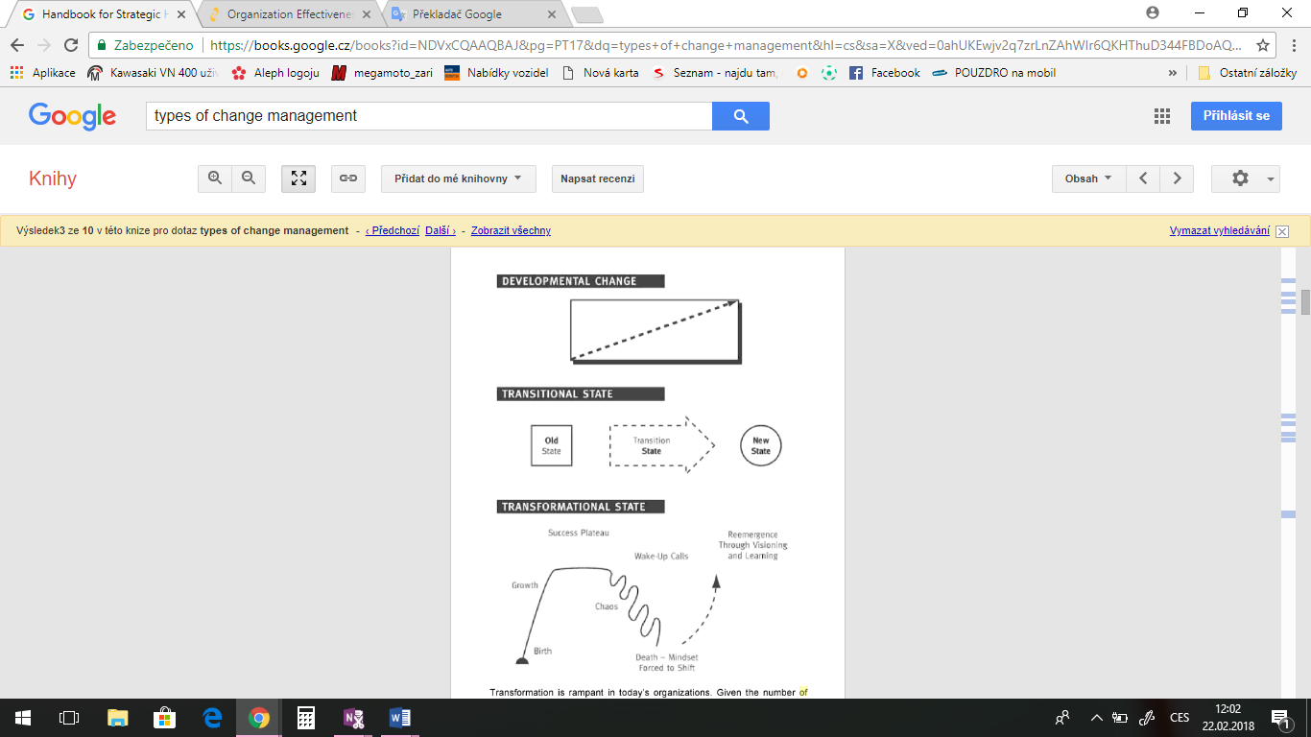

Transformation is rampant in today´s organizations. Given the number of failures, it is forcing executives and consultants to také more blinders off and expand their awareness of what is required and their skills for handling those requirements. How can executives or consultants expect to succeed in the transformational journey if their guidance systems don´t allow them to see or understand the variables they face along the way?

Transformation is unique in two critical ways. First, the future is unknown at the start of the change process and can only be created by forging ahead with the intent to discover it. Without having a clear goal to manage to, leaders are forced to proceed into the inknown, dependent on broader sources of information and support to formulate a new future and puti t into place.

Because the future state is not clear at the beginning, the process for getting there cannot be clear either. A time-bound predetermined plan is not possible. Since the change process cannot be „managed,“ a new way of leading it is needed.

Secondely, the future state is so radically different than the current state that a shift of mindset is required to invent it, let alone implement and sustain it. This fact triggers enormous human and cultural impacts. Leaders and employees alike must transform their mindsets, behavior, and ways of working together. Subsequently, cultural norms must cange to free up these new ways of being. People must certainly change what they do in transformation, but more importantly, they must change the way they think. The strategy for the change must focus on how to accomplish this level of personal change across the organization, leaders included.

These two attributes of transformation make both the process and the human dynamics much more complex, unpredictable and uncontrollable than in either developmental or transitional change. Change management strategies, while helpful, are insufficient for handling these issues. Change leadership strategies that accommodate the realities of transformation are required.

Change leadership demands new executive and consulting competence in three key areas: 1) creating enterprise-wide, integrated transformational change stratégy that attends to all of the people and process dynamics of transformational change, 2) transforming the mindsets of leaders and employees as required by the new marketplace and the transformation itself, and 3) designing, implementing and course correcting the transformational change process. We will discuss each of these chabne leadership arenas (Vogelsang, 2013).

**Planned or emergent change**

One common categorisation used in describing the nature of change is planned or emergent.

Planned. Organisational change is seen as a process of moving from one fixed state to another through a series of pre-planned steps. As such this approach is enirely consistent with a number of theories and ideas including Daft´s key parameters (above). Plans are constructed on the assumtion that organisations operate in stable and/or predictable environments. The emphasis is upon preplanned, rational and systematic, centrally driven, change. Contemporary criticisms centre on issues of employee commitment and the rigidily of the approach.

Emergent. The popularity of alternative approaches including the emergent view arose as the planned approach was challenged as inappropriate given a background of often chaotic environments. The emergent approach is based on a more recent view whereby change is seen as continuous, unpredictable and open ended, a process of constant adjustment to the environment. Emergent change approaches coincided with flatter organizational strucures, demands for increased participation and an open systems approach. Emergent change emphasises a bottom up approach where managers need to facilitate rather than make the change, making sure employees are receptive to changes and suitably skilled.

The former British Prime Minister Benjamin Disraeli observed that change is inevitable in a progressive country. Change is constant. His remark is often reported as the only constant is change. Many of us accept this as a truism yet it is important for organizations to strike a balance between both the forces for stability and inertia and the forces for change. Where the right balance lies, however, will vary from situation to situation. Change is also far from a homogenous concept – it comes in many forms.

A starting point for considering the nature of organizational change is Grundy´s three varieties of change as shown in Figure 2.1. The first, „smooth incremental change“, is change that evolves slowly in a systematic and predictable way. Grundy maintains that this type of change is mainly reminiscent of developer economies from the 1950s to early 1970s, but it became less common by the 1990s. The vertical axis in Figure 2.1 represents the rate of change not the amount of change. Thus, smooth incremental change, at whaever level, happens at a constant rate.

The second variety, „bumpy incremental change“, is characterized by periods of relative tranquility punctuated by acceleration in the pace of change. Grundy likens the „bumps“ to the movement of continental land masses where the „fault“ enables periodic readjustment to occur without cataclysmic effect. Triggers for this type of change are form both the environment and internal changes such as the periodic reorgnizations that organizations go through to improve efficiency. One way of categorizing both types of incremental change is to see them as change that is associated more with the means by which organizations achieve their goals rater than as a change in the goals themselves.

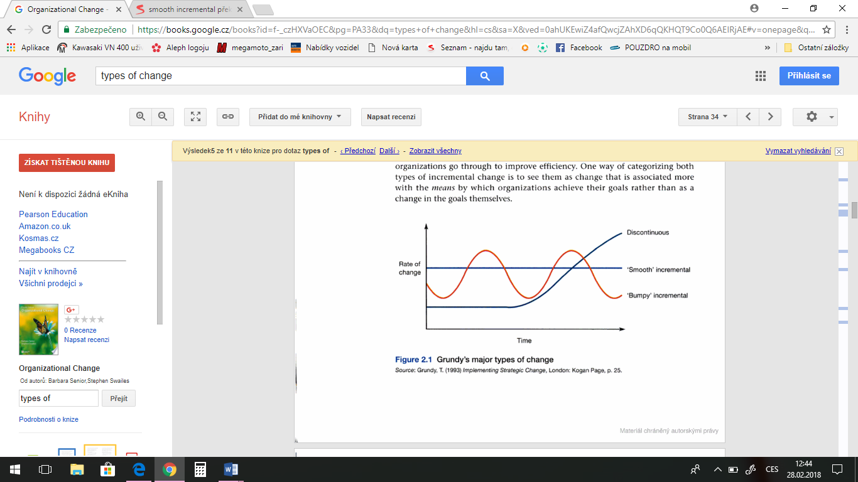

Grundy´s third type is discontinuous change which he defines as change which is marked by rapid shifts in stategy, structure or cultur, or in all three. An example given is the privatization of previously publicly-owned utilities such as elektricity generation and distribution. Another example is what Strebel calls a divergent breakpoint which is change that results forom the discovery of a new business opportunity, such as new ways of communicating and new classes of medicines.

**Source:**

1. Harigopal, K. (2006). *Management of organizational change: Leveraging transformatico* (Second Edition). SAGE Response.
2. Akdeniz, C. (2014). *Change management explained*.
3. Sharma, R. R. (2007). *Change management: Concepts and applications*. India: Tata McGraw-Hill Publishing Company Limited.
4. Lister, E. J. (2005). *Successful Change Management: learn to manage change to achieve performance excellence* (2nd edetion). National Library of Canadian Cataloguing in Publication Data.
5. Taylor & Francis. (2007). *Change management*. Pergamon Flexible Learning.
6. Hiatt, Jeffrey, M., Creasey, & Timothy, J. (2003). *Change management: the People Side of change*.
7. Ramanathan, T. R. (2009). *The role of organisational change management in offshore outsourcing of information technology services: qualitative case studies from a multinational pharmaceutical company*. Boca Raton, Fla: Dissertation.com.
8. Knowledge, S., & Simms, H. (2005). *Organisational Behaviour and Change management*. Select Knowledge Limited.
9. Nilakant, V., & Ramnarayan, S. (2006). *Change management: Altering mindsets in a Global context*. Response Books.
10. Vukotich, G. (2011). *10 Steps to Successful Change Management*. ASTD Press.
11. Kondalkar, V. G. (2009). *Organization Effectiveness and Change management*. New Delhi: PHI Learning Private Limited.
12. Vogelsang, J. (c2013). *Handbook for strategic HR: best practices in organizational development from the OD network*. New York: American Management Association.
13. Senior, B., & Fleming, J. (2006). *Organizational change* (Third edition). Prentice Hall.

17 of the biggest differences between managers and leaders [Online]. (2016). Retrieved March 06, 2018, from http://www.businessinsider.com/biggest-differences-between-managers-and-leaders-2016-3

2. 4 Things Successful Change Leaders Do Well [Online]. (2016). Retrieved March 07, 2018, from https://hbr.org/2016/01/4-things-successful-change-leaders-do-well

3. Are You a Change Leader? [Online]. (2014). Retrieved March 07, 2018, from http://jimcanterucci.com/change-leader/

4. FEMALE LEADERSHIP ADVANTAGE AND DISADVANTAGE: RESOLVING THE CONTRADICTIONS [Online]. (2007). Retrieved March 06, 2018, from http://onlinelibrary.wiley.com/doi/10.1111/j.1471-6402.2007.00326.x/full

5. FEMALE LEADERSHIP ADVANTAGE AND DISADVANTAGE: RESOLVING THE CONTRADICTIONS [Online]. (2007). Retrieved March 06, 2018, from http://citeseerx.ist.psu.edu/viewdoc/download?doi=10.1.1.907.502&rep=rep1&type=pdf

6. Good Leaders Are Invaluable To A Company. Bad Leaders Will Destroy It [Online]. (2013). Retrieved March 07, 2018, from https://www.forbes.com/sites/amyanderson/2013/01/14/good-leaders-are-invaluable-to-a-company-bad-leaders-will-destroy-it/#1d53ac511138

7. How to Be a Successful Change Leader [Online]. (2018). Retrieved March 07, 2018, from https://www.ccl.org/articles/leading-effectively-articles/successful-change-leader/

8. Managers and Leaders: Are They Different? [Online]. (2004). Retrieved March 06, 2018, from https://hbr.org/2004/01/managers-and-leaders-are-they-different

9. Six Characteristics of Highly Effective Change Leaders [Online]. (2010). Retrieved March 07, 2018, from http://innovationexcellence.com/blog/2010/08/20/six-characteristics-of-highly-effective-change-leaders/

10. Six Styles of Leadership: How Will You Handle Your Firm's Reins? [Online]. (2008). Retrieved March 06, 2018, from https://www.americanbar.org/publications/law_practice_home/law_practice_archive/lpm_magazine_articles_v34_is8_pg32.html

11. The Most Important Leaders in World History [Online]. (2017). Retrieved March 07, 2018, from https://www.ranker.com/crowdranked-list/the-most-important-leaders-in-world-history?utm_expid=16418821-388.pwrOe5-lSJetLqzNW0S00A.0&utm_referrer=https%3A%2F%2Fwww.ranker.com%2Fcrowdranked-list%2Fthe-most-important-leaders-in-world-history

14

12. The World's 50 Greatest Leaders [Online]. (2017). Retrieved March 07, 2018, from http://fortune.com/2017/03/23/worlds-50-greatest-leaders-intro/

13. Top 15 Greatest Leaders of All Time [Online]. (2017). Retrieved March 07, 2018, from https://listovative.com/top-15-greatest-history-leaders-of-all-time/

14. What Every Leader Needs to Know About Followers [Online]. (2007). Retrieved March 07, 2018, from https://hbr.org/2007/12/what-every-leader-needs-to-know-about-followers

15. What is the Difference Between Management and Leadership? [Online]. (2009). Retrieved March 06, 2018, from http://guides.wsj.com/management/developing-a-leadership-style/what-is-the-difference-between-management-and-leadership/

16. Women and Top Leadership Positions: Towards an Institutional Analysis [Online]. (2013). Retrieved March 06, 2018, from http://onlinelibrary.wiley.com/doi/10.1111/gwao.12018/abstract

17. Women in the Labor Force: A Databook [Online]. (2006). Retrieved March 06, 2018, from https://www.bls.gov/cps/wlf-databook2006.htm

18. John B. Miner. (1993). *Role motivation theories* (Reprinted). London ; New York: Routledge.

19. Covey, S. (1998). *The 7 habits of highly effective teens* ([Rev. ed.].). New York: Fireside.

20. Fullan, M. (2011). *Change leader learning to do what matters most*. San Francisco: Jossey-Bass/Wiley.

21. Stephen R. Covey. (1997). *The 7 habits of highly effective people* (1st ed.). Provo, UT: Covey Leadership Center.

22. Stephen R. Covey. (2004). *The 7 habits of highly effective people: restoring the character ethic* ([Rev. ed.].). New York: Free Press.

23. Stephen R. Covey. Personal workbook. (2005). *The 7 habits of highly effective people: personal workbook* ([Nachdr.].). Miami: Mango Media Inc.

24. Stephen R. Covey., & [traducción de Jorge Piatigorsky]. (2000). *The 7 habits of highly effective people: wisdom and insight from Stephen R. Covey* (Miniature ed.). Philadelphia: Running Press.

15

25. *The 7 Habits of Highly Effective People: Powerful Lessons in Personal Change*. (2007) (1st ed.). Miami: Mango Media Inc.

26. *Women as transformational leaders*. (c2011) (2nd ed.). Santa Barbara, Calif.: Praeger.

1. Sharma, R. R. (2006). *Change Management.* Tata McGraw-Hill Education.

2. Sheer, A. W., Abolhassan, F., Jost,W. & Kirchmer, M. (2012). *Business Process Change Management: ARIS in Practice.* Springer Science & Business Media.

3. Newton, R. (2012). *Change Management: Financial Times Briefing: The low down on the top job.* Pearson UK.

4. Cliffsnotes.com. *Causes of Organizational Change.* online]. [2016]. Dostupné z www: https://www.cliffsnotes.com/study-guides/principles-of-management/managing-change/causes-of-organizational-change

5. Bizfluent.com. *What are the causes of change in an organization?* [online]. [2017]. Dostupné z www: https://bizfluent.com/info-8230942-causes-change-organization.html

6. Processexcellencenetwork.com. *Nine Reasons Organizations Need To Change.* [online]. [2011]. Dostupné z www: https://www.processexcellencenetwork.com/organizational-change/columns/why-organizations-change-and-what-they-can-change

7. Nibusinessinfo.co.uk. *Business organisation structure.* [online]. [2011]. Dostupné z www: https://www.nibusinessinfo.co.uk/content/reasons-changing-your-organisational-structure

8. Entrepreneurshipinabox.com. *Organizational Change- An diagnostic model.* [online]. [2011]. Dostupné z www: http://www.entrepreneurshipinabox.com/7281/organzational-change-a-diagnostic-model/