

Macroeconomics 2

Moodle blocks 10

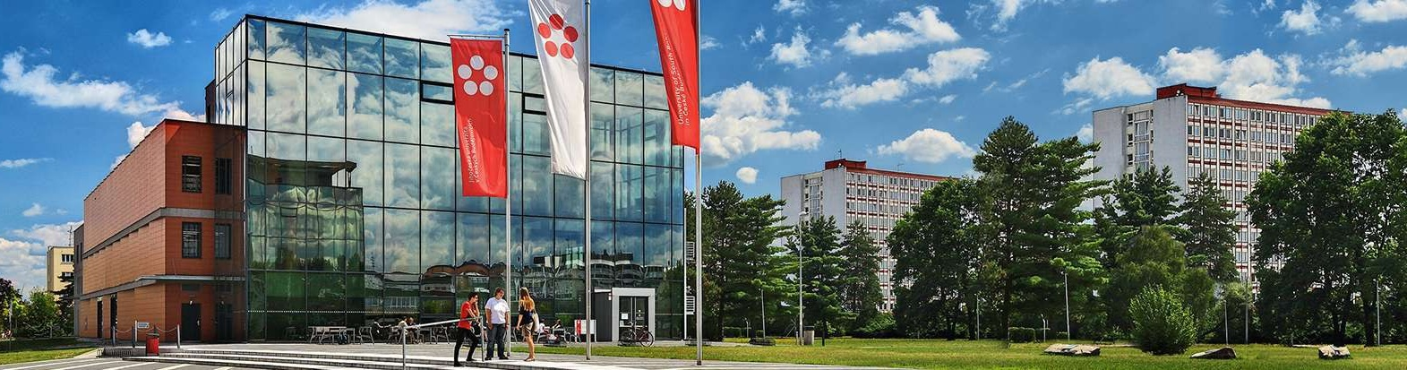

Podtitul dokumentu

Jihočeská univerzita v Českých Budějovicích

Branišovská 1645/31a

370 05 České Budějovice

IČ: 60076658

Formátování:

Normální text

**Silné**

2. Model the IS - LM – BP

1. What the BP curve tells us?
2. By what is influenced the shape of the BP curve and the position?
3. what are the basic prerequisites for perfect capital mobility?
4. Let us suppose that the capital is perfectly mobile, the price level is fixed and the exchange rate flexible. The government will issue several billion to buy new atomic reactors. Describe how this will impact the equilibrium income and interest rate. Current account is changing or not?
5. Equation curve IS
6. Equation curve LM
7. Under the conditions of perfect capital and flexible exchange rates, you have these characteristics of the economy

Aa3 = 1000 c = 0.60 t = 0.25 M = 1200 P = 1.2 b = 4000 h = 6000 k = 0.5 I f = 0.05 m = 0.1 NXa = 650 v = 10

a) Write the IS curve equation and the LM curve equation for this economy

b) Determine the level of equilibrium production and the level of the real exchange rate (R) that clears the property market and graphically illustrate the situation

c) Identify the new product and the exchange rate if the government reduces transfers by 30 billion.

d) Graphically state the situation in fixed and flexible exchange rates

1. Use the following data: if = 0.05 v = 10 k = 0.5 m = 0.2 t = 0.25 Aa3 = 1900

c = 0.65 h = 6000 b = 4000 NXa = 500 M = 1680 P = 1.2

       We expect perfect capital mobility and flexible exchange rates.

a) Write the IS curve equation and the LM curve equation for this economy

b) Determine the level of equilibrium production and the level of the real exchange rate (R) that clears the property market

c) Calculate how the equilibrium income and the real exchange rate change, if government spending increases by 20 billion, and display the graphical situation

d) Graphically illustrate the same situation as in c, but at fixed exchange rates

e) If we come out of the original assignment of a) how the real exchange rate changes after a monetary restriction, when the central bank will lower the money supply by 20 units. Display the situation graphically

f) Graphically illustrate the same situation as in e, but at fixed exchange rates

1. Let us assume perfect capital mobility and flexible exchange rates. The economy is characterized by the following:

C = 40 + 0.85 YD, G = 80 TR = 50 t = 0.25, I = 100-1200F NX = 40- (10 + 0.1Y) M / P =

K = 0.5 h = 3200 v = 10 TAa = 100 NXa = Xa - Ma

a) Write the equation of the IS and LM curve

b) determine the level of equilibrium production and the level of the real exchange rate (R) that clears the goods market.

c) Calculate how the equilibrium income and real exchange rate change will change if government spending is reduced by 40 units

d) Graphically state the situation in fixed and flexible exchange rates

e) Calculate how the equilibrium income and the real exchange rate change if the output from the original assignment is a) if the central bank's monetary expansion is 15 units

f) Graphically state the situation in fixed and flexible exchange rates