Name:

**FINAL TEST**

1. **Explain the following words in English or give a synonym**

abandon

_____________________________________________________________________

assessment

_____________________________________________________________________

commitment _____________________________________________________________________

chiropody

_____________________________________________________________________

scrub nurse

_____________________________________________________________________

**/5**

1. **Fill in the text with the correct word from the box below**

**Volunteerism, Skill Development and Opportunity**

Depending on the ___________ position that you choose to pursue, there may be new ___________ that you develop along the way, some of which may be helpful at any point in your career.

Let’s say you volunteer at a city homeless _____________ that relies on both donations from the community and grant money from foundations and charitable organisations. ____________the time comes for a particular grant to be renewed, you sign up as a member of the fundraising/grant-writing committee at the shelter.

Through this experience, you learn a great deal about fundraising and feel very grateful for the opportunity to gain knowledge of things that are a far cry from what you learned during your nursing studies.

Several years later, you apply for a position as the Executive Director of a medical clinic for at-risk ______________ in need of low-cost or free medical _____________. When you interview with the clinic’s Board of Directors, you realise that, while they’re certainly ______________ in your clinical skills, they’re even more thrilled that you’ve written several successful grants.

In the end, that very skill is the one that makes you stand out among the crowd of ______________ for the position, and you’re hired largely due to what you know from time spent at the shelter.

Community service looks good on an application for a university degree program since the school may be seeking applicants who have a sense of _______________ for those less fortunate.

Both hiring managers for clinical ___________ positions and university admissions teams may look favourably upon the ways in which you’ve given back to your fellow citizens.

They may also look positively upon your memberships in various nursing or medical associations, and it certainly wouldn’t hurt your personal brand if you’ve occupied a leadership position in several of those organisations.

Volunteerism highlights your giving nature and desire to help others.

Who doesn’t want those qualities in a nurse?

(https://www.ausmed.com/)

volunteer

nursing

interested

shelter

When

individuals

skills

care

applicants

compassion

**/10**

1. **Underline the odd word and give one reason why it does not belong in the group:**
2. acute throbbing diarrhoea gnawing
3. dentist geriatrics obstetrician nurse
4. midwife scrub nurse triage nurse mould
5. ache surgery orthopaedics ophthalmology paediatrics
6. benefit shelter relocate assisstance
7. **Choose two pictures from below (A, B, C, D) and describe them. Try to imagine what the problem is and what impression the medical worker leaves on you. There must be min. 5 and max. 15 sentences. The text must be coherent.**

**A**

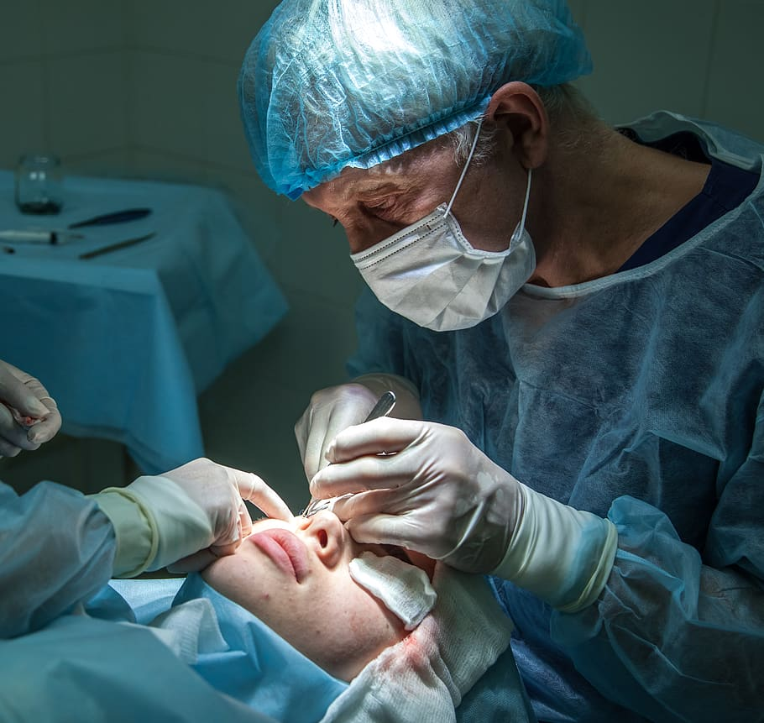

**B**

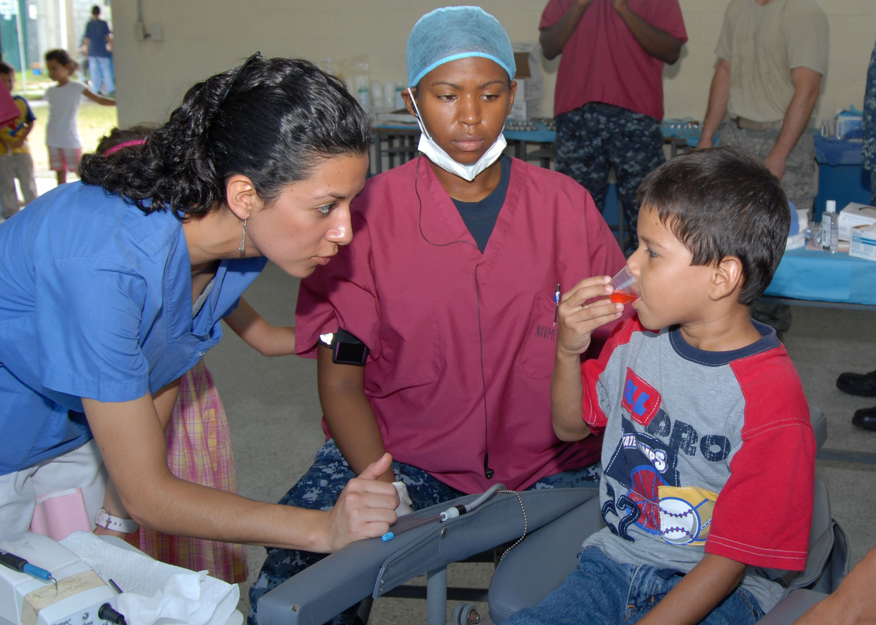

**C**



**D**

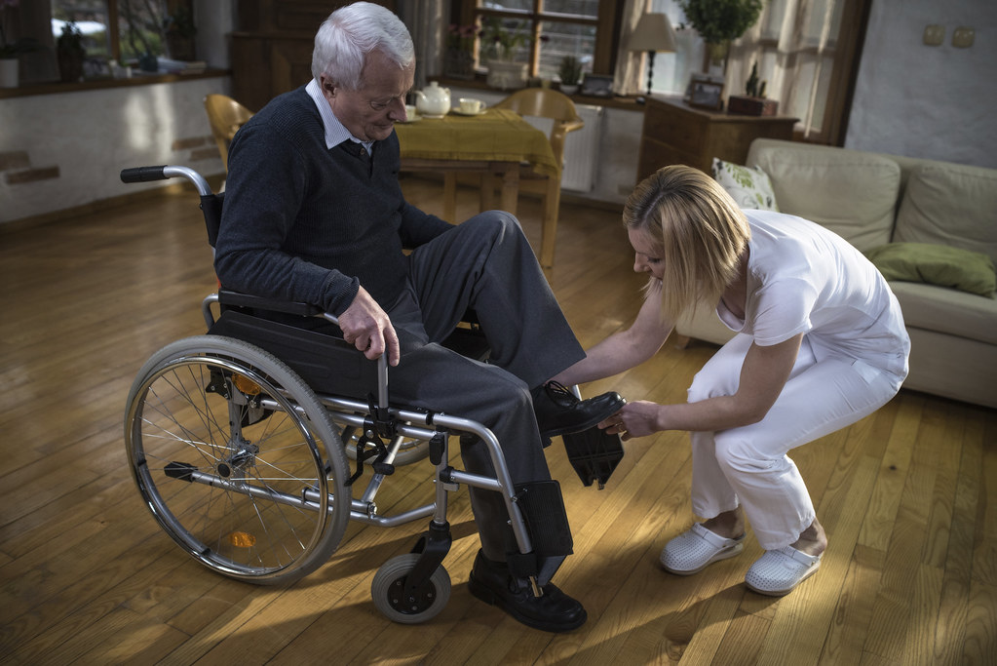

**/10**