určený k procvičování

1. For each question complete the second sentence so that it means the same as the first, using exactly three words:

- I was fascinated by dolphins when I was very young and I still am.
I have been fascinated by dolphins ………………………..…. very young.
- Perhaps there are some people who don’t realise how intelligent dolphins are.
Some people ……………………. how intelligent dolphins are.
- A second ago I received an email inviting me to a lecture on dolphins.
I ………………….. an email inviting me to a lecture on dolphins.
- If you want to come too, it’s necessary to book tickets in advance.
If you want to come too, you …………………… tickets in advance.
- Her boyfriend is not very generous; he always pays for himself only.
She has a …………………… .

2. Complete the following sentences using the words form the box. Use each word only once:

since still so far ever yet just never already lately for

- I have worked for this company __________ a long time.
- I’ve __________ been to my mum’s homeland before.
- We are thrilled; she has __________ given birth.
- Have you done your homework __________? It’s taking you ages!
- She’s been really nervous __________.
- I haven’t seen my best friend __________ the graduation.
- We haven’t seen her new baby __________.
- We have sold 5,000 products __________.
- She __________ hasn’t sorted out her documents.
- Have you __________ visited the Eiffel Tower?
3. Choose the correct word for each space:

It’s very cold today. In fact, it’s (1) ____________ freezing. I hope it’s better on Friday, because our history class is going on a school (2) _____________ to the countryside. We are going to look for old objects that are buried under the ground. This is (3) ________________ more exciting than it sounds, because some of these things can be (4) _______________ valuable. For example, a boy I (5) ______________ at a party last year had found an ancient coin worth $ 2,000. I was (6) ____________ that something so small could be so valuable. Unfortunately, it’s not always easy to find these things, because some of them can be (7) __________________ deep as 2 metres underground and we (8) _______________ use special equipment to find them. It would be great to find something valuable, like a box of Roman gold, but we would probably be satisfied (9) ________________ an old plate or something like that. We are basically interested (10) _______________ finding anything. Of course, we (11) __________ find nothing, but on the other hand, I am very proud (12) _________________ my collection of old shards .
1 too very so absolutely
2 trip travel journey voyage
3 little lot much many
4 not quite seldom easy
5 found met discovered knew
6 surprise surprised surprising surprises
7 very almost so as
8 must have should could
9 of with for about
10 in with for about
11 should could can might
12 of with for about

4. Use the verbs in the brackets in their appropriate forms:

Harvard University 1) __________ (be) the oldest university in the USA. The university 2) __________ (start) in 1636 and it 3) __________ (get) its name two years later when John Harvard 4) __________ (die) and 5) __________ (give) a library to the university. Since then, the university 6) __________ (grow) and Harvard 7) __________ (become) one of the most famous universities in the world. People all over the world 8) __________ (hear) about Harvard! Many famous people 9) __________ (study) at Harvard, including the poet T. S. Eliot among others. Many Harvard students 10) __________ (win) Nobel Prizes. Education at Harvard 11) __________ (change) a lot over its history. Charles Eliot, president of Harvard from 1869-1909, 12) __________ (make) the biggest changes. When he 13) __________ (become) president, students 14) __________ (not take) the entrance exams.
Nowadays, thousands of students 15) __________ (want) to study at Harvard but only about 10% of them 16) __________ (pass) the entrance exams. Nonetheless, Harvard 17) __________ (never, be) only about education. Sport and culture 18) __________ (always, be) very important, too, although the education 19) __________ (play) a more important role in the past than it 20) __________ (play) today.

5. Describe the following people. What are they wearing?:

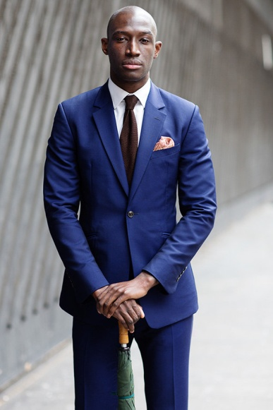

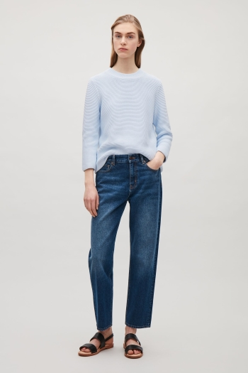

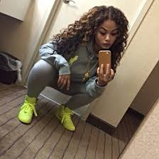

6. Complete the following sentences with the correct form of these words or expressions. Use each word / expression once only:

be find out get to know go know meet

- I …………… Joanne at a party and we got married two years later.
- Tim ………………….. to the cinema, and I have no idea when he’ll get back.
- I ……………….a bit of Japanese when I was younger, but I’ve forgotten most of it now.
- At first I didn’t like Hen, but when I …………………. her better, I thought she was great.
- I was furious when I first ………………… that Jake had used my computer without asking me.
- I ………………… to London only once and I didn’t like it very much.

7. Translate:

- Je možné, že máš pravdu (4 slova).

___________________________________________________________________

- Ráda nosím módní oblečení (5 slov).

___________________________________________________________________

- Zjistil jsem některá překvapivá fakta (6 slov).

___________________________________________________________________

- Právě jsem si koupil dvoje kalhoty (8 slov).

___________________________________________________________________

- Na akci je jednoduchý přístup pomocí MHD (8 slov).

___________________________________________________________________

- Film vychází z románu Emily Brontë (10 slov).

___________________________________________________________________
8. Correct the errors:
- I have felt a bit embarrassing yesterday.
- Prague is a best place I have never been.
- We have gone to the theatre thrice this month.
- The film already received very good critics.
- The show last about 2 hours with two short pauses.
- I don’t like go to the swimming pool, because I can’t swimming.
- He’s gone to New York 2 years ago.
- My thighs are quite fat, so I don’t like wear tights jeans.

