**1. What do you say to express the situation in the picture? Tick the right option(s) ( / 8):**

|  |  |  |  |
| --- | --- | --- | --- |
| https://img.clipartfest.com/5112794178c98661fa240226357e2228_cartoon-of-woman-picking-up-a-heavy-cartoon-woman-clipart_882-1300.jpeg | Výsledek obrázku pro timetable train | Výsledek obrázku pro  shopping bag with tomatoes clipart | Výsledek obrázku pro kickoff football clipart |
| Wait, I’m going to help you. | The Helsinki train is going to leave at 04:18. | Oh, you are going to make vegetable salad (100%). | Who do you think is going to win? |
| Wait, I’m helping you. | The Helsinki train is leaving at 04:18. | Oh, you are making vegetable salad (70%). | Who do you think is winning? |
| Wait, I’ll help you. | The Helsinki train will leave at 04:18. | Oh, you will make vegetable salad. | Who do you think will win? |
| Wait, I help you. | The Helsinki train leaves at 04:18. | Oh, you make vegetable salad. | Who do you think wins? |

**2. Complete the following conditional sentences ( / 12):**

1. Come on, John! You will miss (miss) the train if you don’t hurry (not hurry).
2. Shame, I don’t have enough money. If had (have), I would buy (buy) a new speakers.
3. It’s raining, so we’re not going out. We would get wet (get wet) if we went out (go out).
4. I must go and see Ann sometimes. Actually, if I have (have) time, I will go (go) today.
5. It’s not a very nice place. I wouldn’t go (not go) if I were (be) you.
6. If the weather is (be) right, we always go (always go) for a trip in the mountains.

**3. Finish the sentences in an appropriate way ( / 8):** *různé možnosti - časy dodržet!*

1. If I won a million, I’d buy a new house.
2. If the roads are wet, there are more accidents.
3. If I graduate this year, I will take a year off to travel around the world.
4. I get very tired, if I work hard all day.

**4. Make responses as indicated. Write more options where possible: ( /12):**

1. “I have never been to India” - You (-): I haven’t been to India, either. / Me neither. /

Neither have I.

1. “She’s got a dog” - You (-): I haven’t.
2. “They will get married sometime” - You (+): I will get married sometime, too. / Me

too. / So will I.

1. “I don’t understand!” - You (+): I do.

**5. Correct the errors: ( /12):**

1. Will you go to the party on Saturday, if they invite you?
2. I arrived in Russia 2 years ago.
3. She has never been to India.
4. She hasn’t visited them yet.
5. Look at those clouds. It is going to rain.

**6. Put in a relative pronoun where necessary: ( /10):**

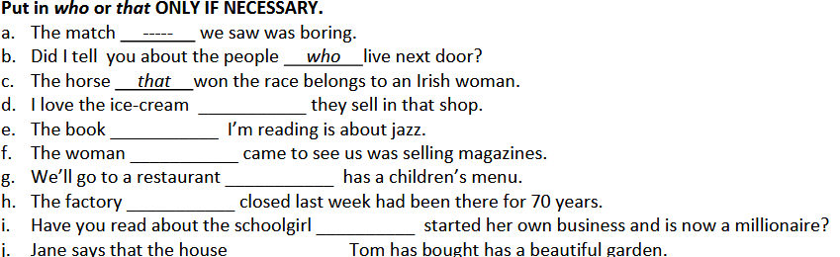

d) Ø, e) Ø, f) who/that, g) which/that, h) which/that, i) who/that, j) Ø

**7. Describe the following people. What do they look like? ( /16):**

|  |  |
| --- | --- |
| Výsledek obrázku pro girl wearing a blouse, skirt, tights boots | She is tall and slim. She’s got brown middle-length wavy hair. |

|  |  |
| --- | --- |
| Výsledek obrázku pro tall man in a suit and bowtie umbrella trainers | He is very tall and slim. He is bold and has got a big nose. He’s got large fingers. |

|  |  |
| --- | --- |
| Výsledek obrázku pro curly hair women, jumper, gloves, jeans | She is of medium height and very thin / skinny. She’s got fair medium-length hair and long arms. She is very pale. |

|  |  |
| --- | --- |
| Výsledek obrázku pro curly woman, tracksuit, trainers | She is quite short and slim. She has got long brown curly hair, short fingers and small feet. |

**8. Correct the errors in these sentences. ( /12):**

a. Joan won the prize, which surprised me a lot.

b. The children that were playing football broke one of my

windows.

c. The house in which I was born has just been demolished.

d. Fred is the man who lives next door.

e. The books which are on the table are mine.

f. I can’t remember the name of the person who I borrowed this pen from.

**9. Label with the correct word ( /10):**

 hitchhike suitcase

 gale  signpost

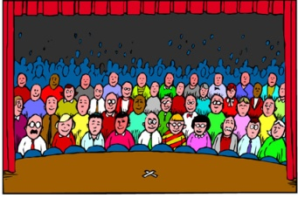 audience  cartoon

 martial arts 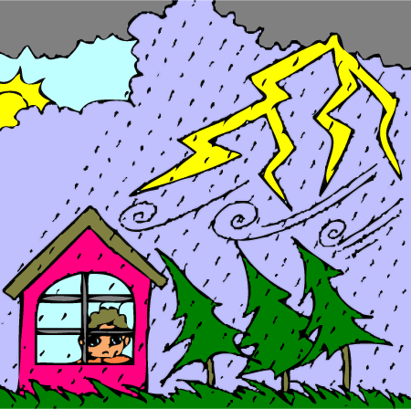 thunderstorm

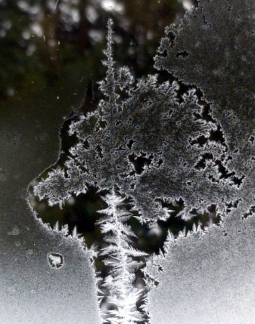 patterns formed by frost  striped